**Aakanksha Malode**

**Database Assignment 1**

Note : Use Emp, dept and salgrade table

1. To list all records with sal > 2000 and comm>200

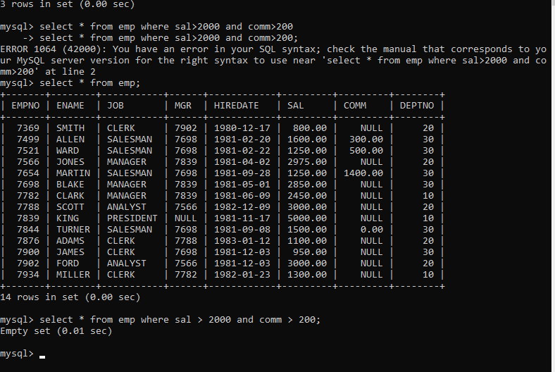

2. To list all record with job=’Clerk’ or sal>2000

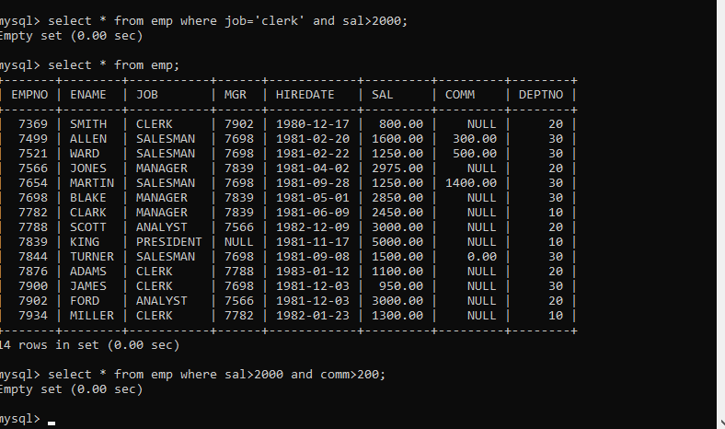

3. To list all the record with sal=1250 or 1100 or 2850

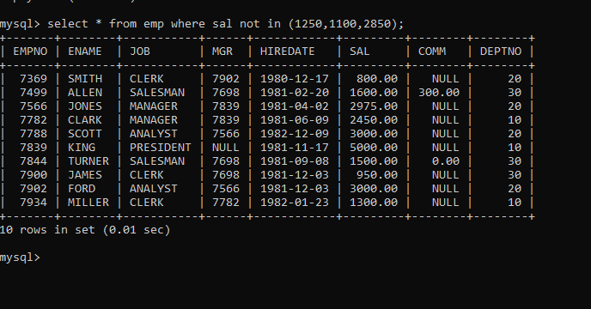

4. To list all employees with sal>1250 and <2850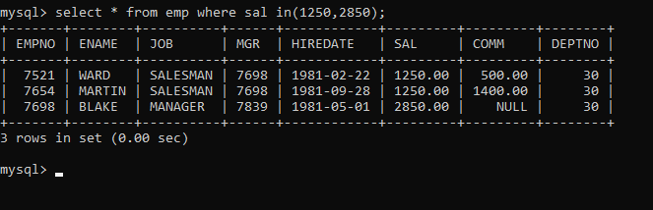

5. To list all employees with name ends with AS

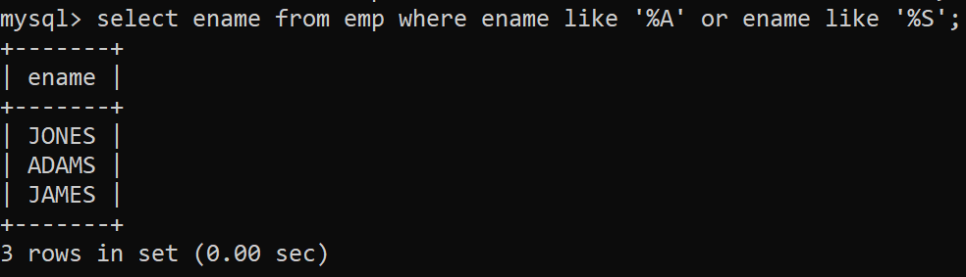

6. To list all employees with job starts with C and ends with K

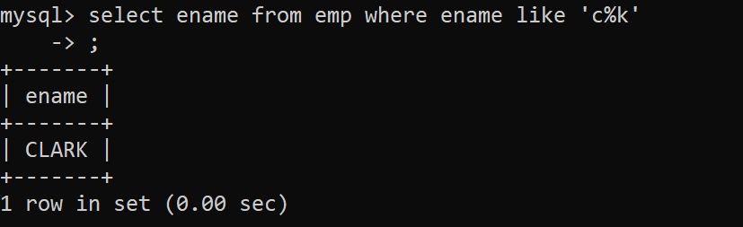

7. To list all employees with job contains L at third position and

M at third last position

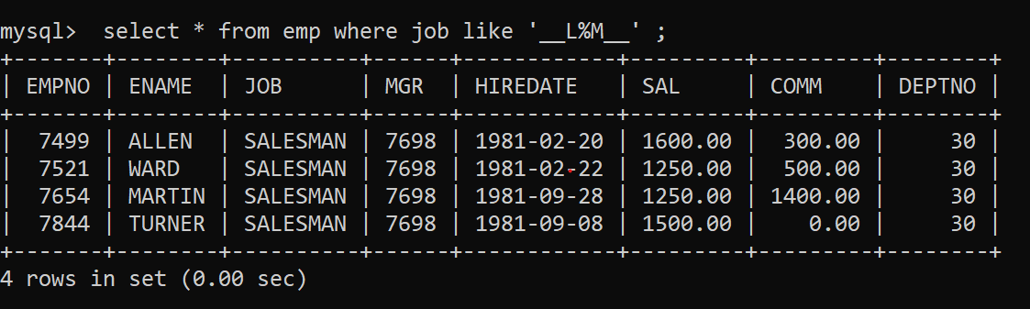

8. To list all the record with sal not equal to 1250 or 1100 or 2850

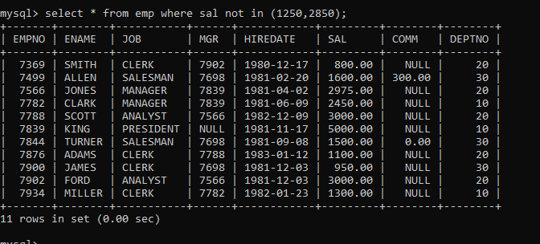

9. To list all employees with salnot >1250 and <2850

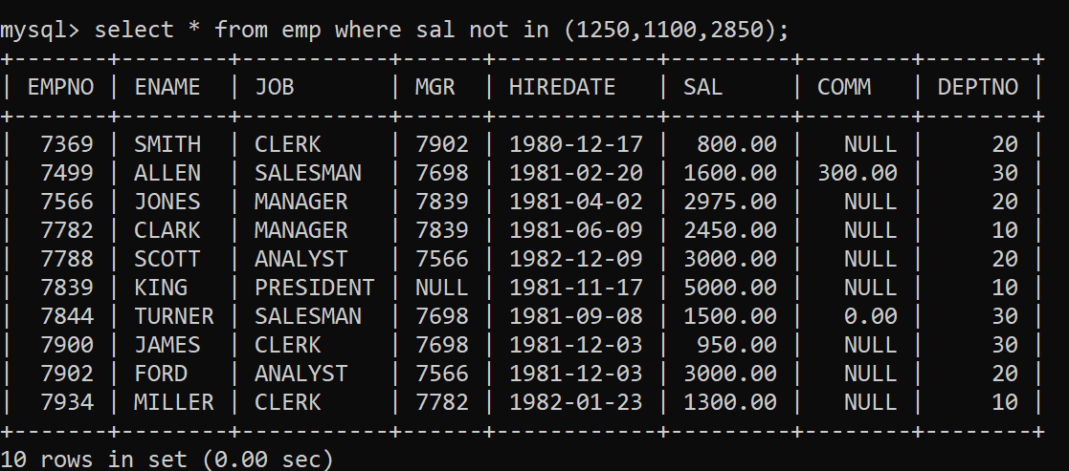

10. To list all employees with job starts with C , E at 3rd position and ends with K

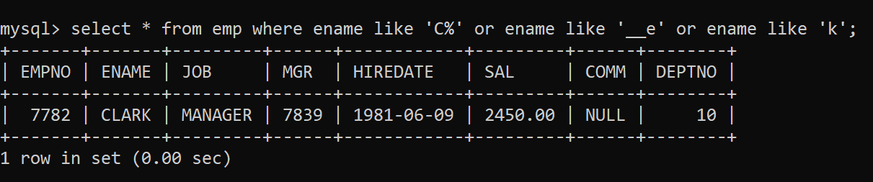

11. To list all rows with comm is null

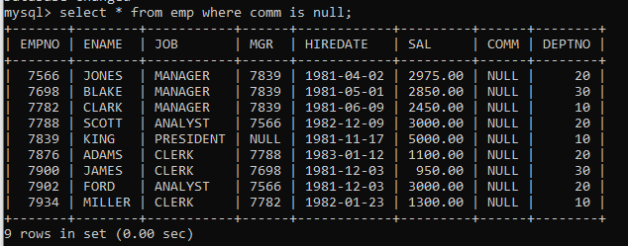

12. To list all employees with sal is null and name starts with ‘S’



13. To list all employees with job contains 5 characters.

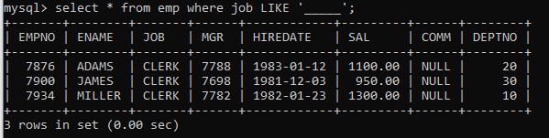

14. To list all employees with name contain ‘A’ at 1 position and job

Contains 5 characters

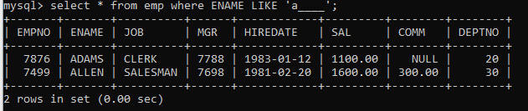

Q2. Solve the following

1. Retrieve the details (Name, Salary and dept no) of the emp who are working in department code 20, 30 and 40.

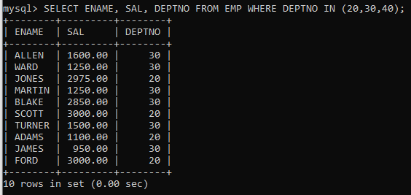

2. Display the total salary of all employees . Total salary will be calculated as sal+comm+sal*0.10

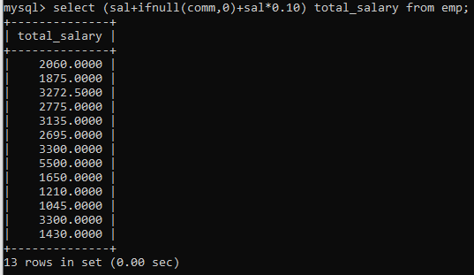

3. List the Name and job of the emp who have joined before 1 jan 1986 and whose salary range is between 1200and 2500. Display the columns with user defined Column headers.

4. List the empno, name, and department number of the emp works under manager with id 7698

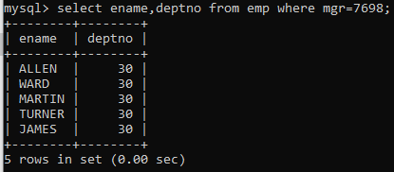

5. List the name, job, and salary of the emp who are working in departments 10 and 30.

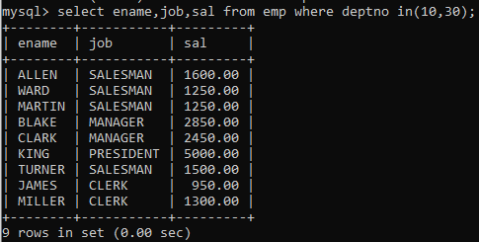

6. Display name concatenated with dept code separated by comma and space. Name the column as ‘Emp info’.

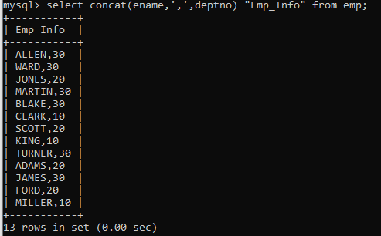

7. Display the emp details who do not have manager.

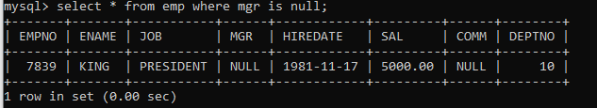

8. Write a query which will display name, department no and date of joining of all employee who were joined January 1, 1981 and March 31, 1983. Sort it based on date of joining (ascending).

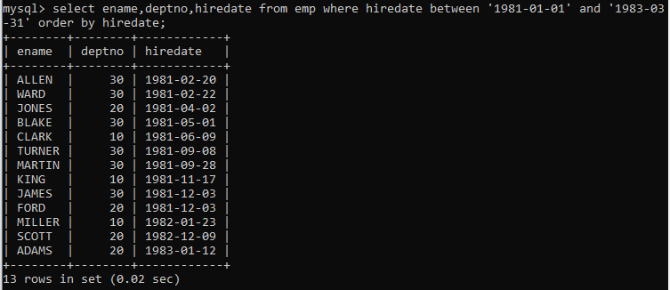

9. Display the employee details where the job contains word ‘AGE’ anywhere in the Job

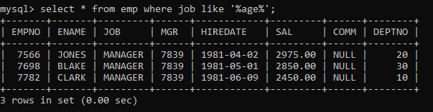

11. List the details of the employee , whose names start with ‘A’ and end with ‘S’ or whose names contains N as the second or third character, and ending with either ‘N’ or ‘S’.

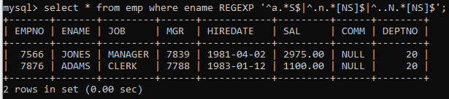

12. List the names of the emp having ‘_’ character in their name.

Single Row functions



1. To list all employees and their email, to generate email use 2 to 5 characters from ename Concat it with 2 to 4 characters in job and then concat it with ‘@mycompany.com’

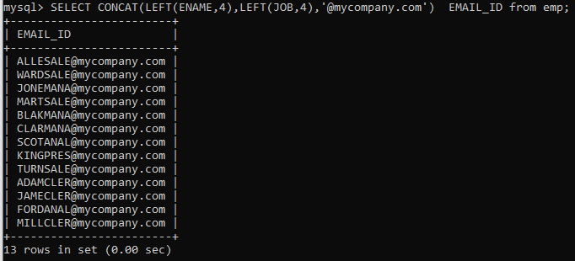

2. List all employees who joined in September.

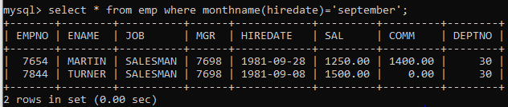

3. List the empno, name, and department number of the emp who have experience of 18 or more years and sort them based on their experience.

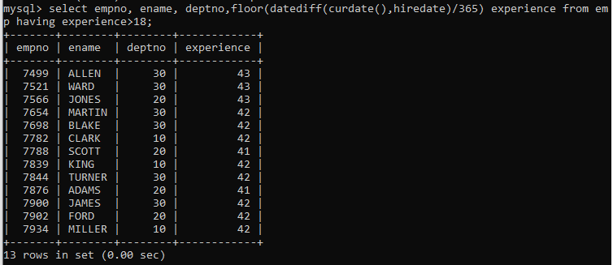

4. Display the employee details who joined on 3rd of any month or any year

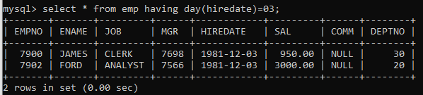

5. display all employees who joined between years 1981 to 1983.

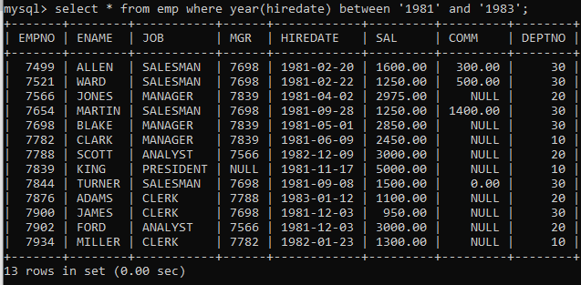

**Group functions**

6. Display the Highest, Lowest, Total & Average salary of all employee. Label the columns Maximum, Minimum, Total and Average respectively for each Department. Also round the result to the nearest whole number.

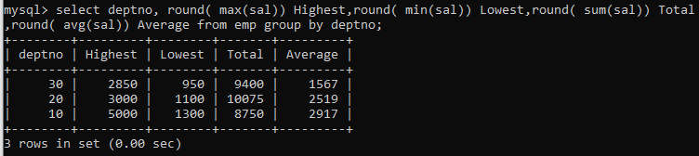

7. Display Department no and number of managers working in that department. Label the column as ‘Total Number of Managers’ for each department.

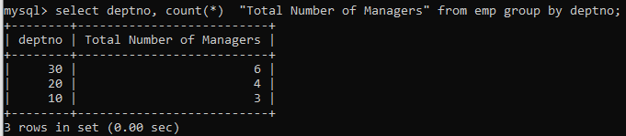

8. Get the Department number, and sum of Salary of all non managers where the sum is greater than 20000.



Date and Time functions

1. Write a query to display the first day of the month (in datetime format) three months before the current month.

Sample current date : 2014-09-03

Expected result : 2014-06-01

2. Write a query to display the last day of the month (in datetime format) three

months before the current month.

3. Write a query to get the distinct Mondays from hiredate in emp tables.

4. Write a query to get the first day of the current year.

5. Write a query to get the last day of the current year.

6. Write a query to calculate your age in year.

7. Write a query to get the current date in the following format.

Sample date : 04-sep-2014

Output : September 4, 2014

8. Write a query to get the current date in Thursday September 2014 format.

Thursday September 2014

9. Write a query to extract the year from the current date.

10. Write a query to get the first name and hire date from employees table

where hire date between '1987-06-01' and '1987-07-30'

11. Write a query to display the current date in the following format.

Sample output: Thursday 4th September 2014 00:00:00

12. Write a query to display the current date in the following format.

Sample output: 05/09/2014

13. Write a query to display the current date in the following format.

Sample output: 12:00 AM Sep 5, 2014

14. Write a query to get the employees who joined in the month of June.

15. Write a query to get the years in which more than 10 employees joined.

16. Write a query to get first name of employees who joined in 1987.

17. Write a query to get employees whose experience is more than 5 years.

18. Write a query to get employee ID, last name, and date of first salary of the

employees.

19. Write a query to get first name, hire date and experience of the

employees.

Sample table: employees

20. Write a query to get the department ID, year, and number of employees joined.

player (player_id, pname,speciality,date_of joining,num_matches,team_id)

team(team_id, tname,player_num)

matches(match_id, team1_id,team2_id,match_date,winner,man_of_the match)

simple query

1. display all players playerid, player name and experience

2. display all player with experience > 5 years

3. display all players joined in march month, any year

4. display all players joined in march 1995

5. display all player with number of matches played are either 5 or 10 or 8

6. display all employees who are either batsman, bowler

7. display all employees who joined in year 1995 or 1996 or 1997

8.

Nested query

1. list all player who plays in virat kohalis team

2. list all players who played matches in year 2024

3. list all matches in which man of the match is from team1

4. list all matches in which man of the match is from team1

5. list all matches in which csk team win.

6. list all matches in which either csk or rcb team won the match

7. list all teams who one atleast one match

8. list all teams who does not played any match

9. list all team name, in which no players are their

10. list all players who are in dhoni’s team

11. list all players who are in either dhoni’s or virat’s team

12. find all team names who one more than 3 matches

Vehicle

Vid Vname Price desc

1 Activa 80000 ksldjfjksj

2 Santro 8,00000 kdjfkjsd

3 Motor bike 100000 fdkdfj

customer

Custid Cname address

1 Nilima Pimpari

2 Ganesh Pune

3 Pankaj Mumbai

salesman

Sid Sname adress

10 Rajesh mumbai

11 Seema Pune

13 Rakhi pune

cust-vehicle (customer is buying Many vehicle and 1 vehicle can be bought by many customers)

Custid Vid Sid Buy_price

1 1 10 75000

1 2 10 7,90,000

2 3 11 80000

3 3 11 75000

3 2 10 8,00000

1. create all given tables

2. create index on vehicle table based on price

3. find all customer name,vehicle name, salesman name, discount earn by all customer

4. find all customer name,vehicle name,salesman name for all salesman who stays in pune

5. find how many customers bought motor bike

6. create a view find_discount which displays output

-------to create view

create view find_discount

as

select cname,vname,price,buying_price,price-buying_price “discount”

from customer c inner join cust_vehicle cv on c.custid=cv.cid inner join vehicle v on

v.vid=cv.vid

--------to display discount

select * from find_discount;

7. find all customer name, vehicle name, salesman name, discount earn by all customer

8. create view my_hr to display empno,ename,job,comm for all employees who earn

commission

9. create view mgr30 to display all employees from department 30

10. insert 3 employees in view mgr30 check whether insertion is possible

11. insert 3 records in dept and display all records from dept

12. use rollback command check what happens

13. do the following

insert row in emp with empno 100

insert row in emp with empno 101

insert row in emp with empno 102

add savepoint A

insert row in emp with empno 103

insert row in emp with empno 104

insert row in emp with empno 105

add savepoint B

delete emp with empno 100

delete emp with emp no 104

rollback upto svaepoint B

check what all records will appear in employee table

rollback upto A

check what all records will appear in employee table

commit all changes

check what all records will appear in employee table

check whether you can roll back the contents.

14. create a procedure getMin(deptno,minsal) to find minimum salary of given table.

**PL-SQL**

Solve the following

1. write a procedure to insert record into employee table.

the procedure should accept empno, ename, sal, job, hiredate as input parameter

write insert statement inside procedure insert_rec to add one record into table

create procedure insert_rec(peno int,pnm varchar(20),psal decimal(9,2),pjob

varchar(20),phiredate date)

begin

insert into emp(empno,ename,sal,job,hiredate)

values(peno,pnm,psal,pjob,phiredate)

end//

2. write a procedure to delete record from employee table.

the procedure should accept empno as input parameter.

write delete statement inside procedure delete_emp to delete one record from emp

table

3. write a procedure to display empno,ename,deptno,dname for all employees with sal

> given salary. pass salary as a parameter to procedure

4. write a procedure to find min,max,avg of salary and number of employees in the

given deptno.

deptno --→ in parameter

min,max,avg and count ---→ out type parameter

execute procedure and then display values min,max,avg and count

5. write a procedure to display all pid,pname,cid,cname and salesman name(use

product,category and salesman table)

6. write a procedure to display all vehicles bought by a customer. pass cutome name as

a parameter.(use vehicle,salesman,custome and relation table)

7. Write a procedure that displays the following information of all emp

Empno,Name,job,Salary,Status,deptno

Note: - Status will be (Greater, Lesser or Equal) respective to average salary of their own

department. Display an error message Emp table is empty if there is no matching

record.

8. Write a procedure to update salary in emp table based on following rules.

Exp< =35 then no Update

Exp> 35 and <=38 then 20% of salary

Exp> 38 then 25% of salary

9. Write a procedure and a function.

Function: write a function to calculate number of years of experience of employee.(note:

pass hiredate as a parameter)

Procedure: Capture the value returned by the above function to calculate the additional

allowance for the emp based on the experience.

Additional Allowance = Year of experience x 3000

Calculate the additional allowance

and store Empno, ename,Date of Joining, and Experience in

years and additional allowance in Emp_Allowance table.

create table emp_allowance(

empno int,

ename varchar(20),

hiredate date,

experience int,

allowance decimal(9,2));

10. Write a function to compute the following. Function should take sal and hiredate

as i/p and return the cost to company.

DA = 15% Salary, HRA= 20% of Salary, TA= 8% of Salary.

Special Allowance will be decided based on the service in the company.

< 1 Year Nil

>=1 Year< 2 Year 10% of Salary

>=2 Year< 4 Year 20% of Salary

>4 Year 30% of Salary

11. Write query to display empno,ename,sal,cost to company for all employees(note:

use function written in question 10)

Q2. Write trigger

1. Write a tigger to store the old salary details in Emp _Back (Emp _Back has the

same structure as emp table without any

constraint) table.

(note :create emp_back table before writing trigger)

----- to create emp_back table

create table emp_back(

empno int,

ename varchar(20),

oldsal decimal(9,2),

newsal decimal(9,2)

)

(note :

execute procedure written in Q8 and

check the entries in EMP_back table after execution of the procedure)

2. Write a trigger which add entry in audit table when user tries to insert or delete

records in employee table store empno,name,username and date on which

operation performed and which action is done insert or delete. in emp_audit table.

create table before writing trigger.

create table empaudit(

empno int;

ename varchar(20),

username varchar(20);

chdate date;

action varchar(20)

);

3. Create table vehicle_history. Write a trigger to store old vehicleprice and new vehicle

price in history table before you update price in vehicle table

(note: use vehicle table).

create table vehicle_history(

vno int,

vname varchar(20),

oldprice decimal(9,2),

newprice decimal(9,2),

chdate date,

username varchar(20)

);

Assignment 1 :

1. Create the table SEMP with the following structure:-

EMPNO CHAR(4)

EMPNAME CHAR(20)

BASIC FLOAT(9,2)

DEPTNO CHAR(2)

DEPTHEAD CHAR(4)

2. Create the table SDEPT with the following structure:-

DEPTNO CHAR(2)

DEPTNAME CHAR(15)

3. Insert into the SDEPT table the following values:-

10, Development

20, Training

4. Insert into the SEMP table the following values:-

0001, SUNIL, 6000, 10

0002, HIREN, 8000, 20

0003, ALI, 4000, 10, 0001

0004, GEORGE, 6000, 0002

Create S, P, J, SPJ tables as specified below and insert a few rows in each table:-

SUPPLIER - S

(S#, Sname, Status, City)

PARTS - P

(P#, Pname, Color, Weight, City)

PROJECTS - J

(J#, Jname, City)

SUPPLIER-PARTS-PROJECT - SPJ

(S#, P#, J#, Qty)

Sample data for S# column:- ‘S1’, ‘S2’, ‘S3’, etc.

Sample data for P# column:- ‘P1’, ‘P2’, ‘P3’, etc.

Sample data for J# column:- ‘J1’, ‘J2’, ‘J3’, etc.

Sample data for Status column:- 10, 20, 30, etc.

Write the SELECT queries to do the following:-

5. Display all the data from the S table.

6. Display only the S# and SNAME fields from the S table.

7. Display the PNAME and COLOR from the P table for the CITY=”London”.

8. Display all the Suppliers from London.

9. Display all the Suppliers from Paris or Athens.

10. Display all the Projects in Athens.

11. Display all the Partnames with the weight between 12 and 14 (inclusive of both).

12. Display all the Suppliers with a Status greater than or equal to 20.

13. Display all the Suppliers except the Suppliers from London.

14. Display only the Cities from where the Suppliers come from.

15. Assuming that the Part Weight is in GRAMS, display the same in MILLIGRAMS

and KILOGRAMS.

Assignment 2:

1. Display the Supplier table in the descending order of CITY.

2. Display the Part Table in the ascending order of CITY and within the city in the

ascending order of Part names.

3. Display all the Suppliers with a status between 10 and 20.

4. Display all the Parts and their Weight, which are not in the range of 10 and 15.

5. Display all the Part names starting with the letter ‘S’.

6. Display all the Suppliers, belonging to cities starting with the letter ‘L’.

7. Display all the Projects, with the third letter in JNAME as ‘n’.

Assignment 3:

1. Display all the Supplier names with the initial letter capital.

2. Display all the Supplier names in upper case.

3. Display all the Supplier names in lower case.

4. Display all the Supplier names padded to 25 characters, with spaces on the left.

5. Display all the Supplier names (with ‘la’ replaced by ‘ro’).

HINT: REPLACE.

6. Execute the above command with the translate function and note the difference in

output.

7. Display the Supplier names and the lengths of the names.

8. Use the soundex function to search for a supplier by the name of ‘BLOKE’.

9. Display the Supplier name and the status (as Ten, Twenty, Thirty, etc.).

10. Display the current day (e.g. Thursday).

Assignment 4:

1. Display the minimum Status in the Supplier table.

2. Display the maximum Weight in the Parts table.

3. Display the average Weight of the Parts.

4. Display the total Quantity sold for part ‘P1’.

5. Display the total Quantity sold for each part.

6. Display the average Quantity sold for each part.

7. Display the maximum Quantity sold for each part, provided the maximum Quantity is

greater than 800.

8. Display the Status and the count of Suppliers with that Status.

9. Display the count of Projects going on in different cities.

10. What is the difference between COUNT(Status) and COUNT(*) ?

11. Display the Status and the Count of Suppliers with that Status in the following format

as shown below:-

Status Count

Ten 1

Twenty 2

Thirty 3

Assignment 5:

1. Display the Supplier name and the Quantity sold.

2. Display the Part name and Quantity sold.

3. Display the Project name and Quantity sold.

4. Display the Supplier name, Part name, Project name and Quantity sold.

5. Display the Supplier name, Supplying Parts to a Project in the same City.

6. Display the Part name that is ‘Red’ is color, and the Quantity sold.

7. Display all the Quantity sold by Suppliers with the Status = 20.

8. Display all the Parts and Quantity with a Weight > 14.

9. Display all the Project names and City, which has bought more than 500 Parts.

10. Display all the Part names and Quantity sold that have a Weight less than 15.

11. Display all the Employee names and the name of their Managers.

Assignment 6:

1. Display all the Suppliers with the same Status as the supplier, ‘CLARK’.

2. Display all the Employees in the same department as the employee ‘MILLER’.

3. Display all the Parts which have more Weight than all the Red parts.

4. Display all the Projects going on in the same city as the project ‘TAPE’.

5. Display all the Parts with Weight less than all the Green parts.

6. Display the name of the Supplier who has sold the maximum Quantity (in one sale).

7. Display the name of the Employee with the minimum Salary.

8. Display the name of the Supplier who has sold the maximum overall Quantity (sum

of Sales).

9. Display the name of the Department with the maximum number of Employees.